The observed out-of-plane (OOP) response of the tested cavity wall specimens can be interpreted through the dynamic interaction of multiple rigid rocking bodies, consistently with the approaches proposed by Doherty 2000, Sorrentino et al 2008, DeJong and Dimitrakopoulos 2014, Grazzioti et al. 2016, Tomassetti et al. 2018, and Casapulla et al. 2017. The proposed mechanism combines the cavity-wall rocking formulation developed by Graziotti et al. (2016) with the multi-body slender wall mechanism proposed by Casapulla et al. (2017), resulting in a hybrid mechanical model capable of representing the complex rocking behaviour observed experimentally in cavity walls with timber floor diaphragms.
Figure 1 schematically illustrates the proposed rigid-body mechanism under both static and dynamic conditions. The cavity wall specimen consists of an inner and outer masonry leaf connected by wall ties and interacting with two timber joist floors. The upper portion of the specimen is represented by the top masonry layer confined by L-shaped steel profiles. This upper layer is allowed to move vertically through a mechanical hinge positioned at the extremity of the steel arm, thereby reproducing the effect of a movable overburden. The timber floors are connected to the inner leaf through pocket supports, while one extremity of each timber diaphragm is free to move horizontally due to the presence of a mechanical hinge. This configuration reproduces the flexible interaction between timber floors and masonry walls typically found in existing cavity wall buildings.
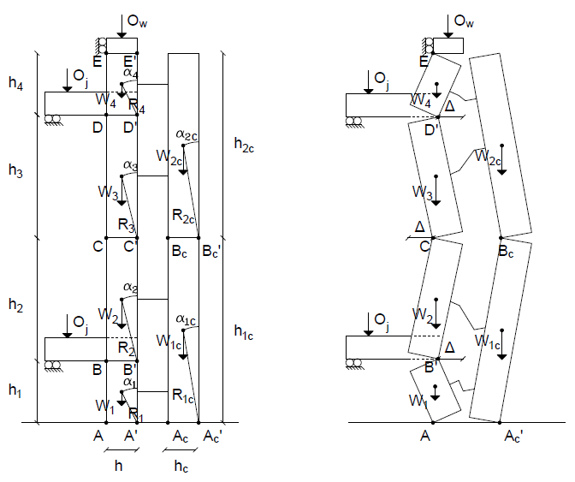
Figure 1. Rigid body (RB) mechanisms: static and dynamic conditions for cavity wall (left, right) specimens.
During the experimental tests, progressive uplift and rocking of the wall caused a migration of the resultant compressive force toward the edge of the wall thickness, as previously observed by Graziotti et al. (2016). Initially, the wall response can be idealised as a rigid-body (RB0) mechanism, in which the axial load acts at the mid-thickness of the wall section. With increasing horizontal displacement and uplift, the resultant force progressively shifts toward the compressed edge, eventually passing through the pivot point $E$. The mechanism therefore transitions into an edge-rocking configuration (RB∆), characterised by concentrated compression at the wall edge and increased geometric nonlinearity.
Experimental observations further revealed that the inner and outer leaves developed different crack patterns and rocking configurations. In the inner leaf, cracking and hinge formation occurred at the levels of the timber joists and at intermediate locations between the floors. Consequently, the inner leaf subdivided into four distinct rigid rocking bodies. Conversely, the outer leaf developed a more global rocking response, with hinge formation concentrated mainly near the mid-height region. Due to the limited height of the masonry portions above and below the timber floors, together with the relatively low number and stiffness of cavity wall ties, additional hinges did not form in these regions of the outer leaf. As a result, the outer leaf behaved predominantly as a two-body rocking system.
The experimentally observed mechanism therefore represents a combination of two established masonry failure mechanisms. The first corresponds to the cavity-wall rocking mechanism proposed by Graziotti et al. (2016), which describes the interaction between the two leaves and the development of rocking between diaphragm levels. The second corresponds to the slender cantilever wall mechanism described by Casapulla et al. (2017), which models the rocking response of vertically spanning masonry portions acting as cantilever rigid blocks. In the present study, these two approaches are integrated into a unified mechanical model capable of reproducing the behaviour of cavity walls interacting with flexible timber diaphragms.
More specifically, the wall segment located between the timber floors is modelled according to the Graziotti et al. (2016) cavity-wall formulation, where the interaction between the inner and outer leaves governs the rocking response. In contrast, the masonry portions located above the upper floor and below the lower floor are modelled according to the cantilever rigid-block approach proposed by Casapulla et al. (2017). These upper and lower portions behave as vertically spanning masonry cantilevers, rocking about their base or diaphragm interfaces. The complete mechanism is therefore represented by a coupled assembly of rigid rocking bodies with different geometrical and boundary conditions.
Following Graziotti et al. (2016), the experimental horizontal force can be evaluated by multiplying the absolute acceleration of each rigid body centre of mass by the corresponding mass. The acceleration of each body is derived from the measured accelerations along the wall height while assuming a rigid-body kinematic response and a linear distribution of relative accelerations. The displacement demand is associated with the relative opening of the critical rocking hinge. The bilinear static capacity curve is then constructed considering the instability displacement and the transition between the centred-load (RB0) and edge-load (RB∆) configurations.
In the proposed formulation, the parameters defining the bilinear relationships are extended by incorporating the cantilever rocking contribution described by Casapulla et al. (2017). Accordingly, the outer leaf contribution is primarily evaluated through the cavity-wall mechanism proposed by Graziotti et al. (2016), while the inner leaf contribution combines the cavity-wall mechanism between floor levels with the cantilever rocking mechanisms of the masonry segments located above and below the timber diaphragms. This combined approach allows the proposed model to capture both diaphragm-induced cantilever rocking and cavity wall behaviour within a unified analytical framework.
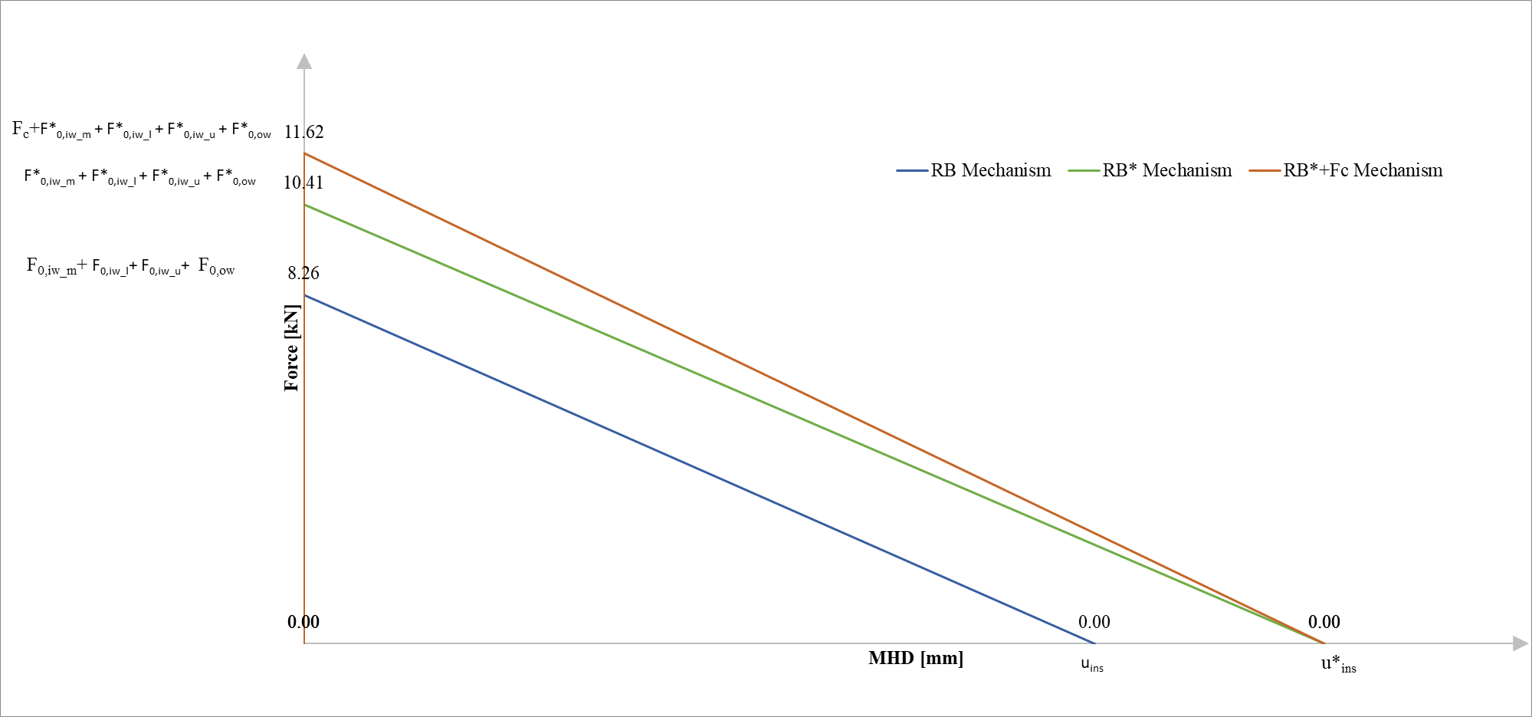
Figure 2. Cavity wall specimen F-u relationships
The proposed model also accounts for the eccentricity associated with the migration of the resultant overburden force along the top edge of the wall. Referring to the bilinear idealisation shown in Figure 2, the force capacities $F_{RB0} (RB0)$, $F_{RBΔ} (RB∆)$, and $F_{RBΔ}+F_{c} (RB∆+F_{c})$, together with the instability displacements $u_{ins}$and $u_{ins,Δ}$, are computed using the following equations, respectively.

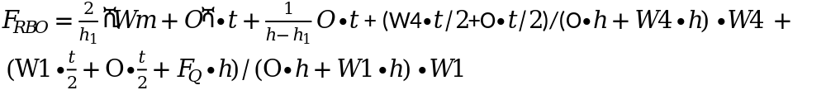
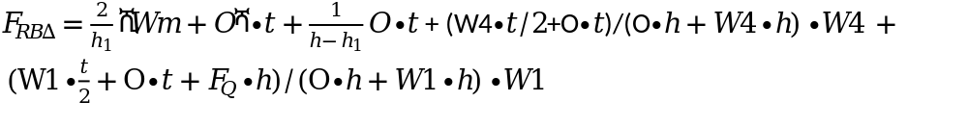
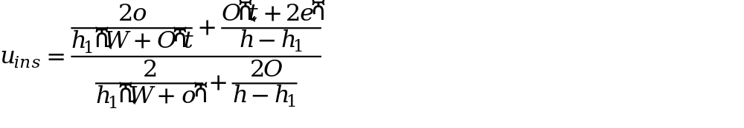
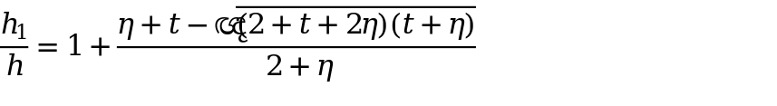
where $η=O/W$is the ratio between the vertical overburden force and the wall self-weight, and $τ=f_{w}/(W/(t⋅w))$is the non-dimensional masonry tensile strength, where $O$is the overburden force, $W$is the masonry weight, $t$is the wall thickness, $e$is the eccentricity. The presence of diaphragm that is simply supported on the inner leaf implies that joists can slip out, acting on the wall with a horizontal friction force, F0, which is cohesionless coulombs law in which equal to F_{Q}=Q.f_{d} where Q is the vertical load including deadload of joist, overburden and weight of the wall transmitted to the wall and f_{d} is the friction coefficient which was taken as 0.6.
In the proposed formulation, the force contributions associated with the inner and outer leaves are evaluated independently and subsequently combined through force superposition, while the instability displacement is governed by the kinematic response of the inner load-bearing leaf. Therefore, the global force capacity is obtained as the sum of the resisting contributions of the two leaves and the coupling action provided by the ties, whereas the instability displacement, uins is assumed equal to that of the inner leaf only while for $u_{ins,Δ}$, it is assumed equal to the thichkness of the masonry wall.
The coupling force contribution provided by the cavity-wall ties can be computed as follows:
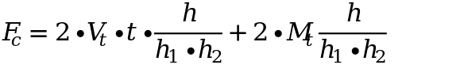
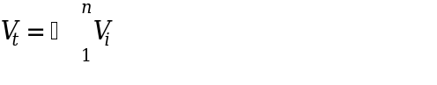
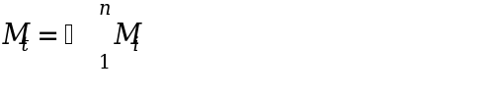
where Vt and Mt are the sum of the n tie plastic moments and the corresponding shears at the inner leaf edge interfaces, respectively. As shown in Figure 2, the force capacity of the cavity wall specimens can be defined as the sum of the force of the two leaves (considered independent of one another) and the coupling force:

References
Doherty KT. An investigation of the weak links in the seismic load path of unreinforced masonry buildings PhD thesis. Australia: University of Adelaide; 2000.
Sorrentino L, Masiani R, Griffith MC. The vertical spanning strip wall as a coupled rocking rigid body assembly. Struct Eng Mech 2008;29:433–53.
DeJong MJ, Dimitrakopoulos EG. Dynamically equivalent rocking structures. Earthquake Eng Struct Dynam 2014;43(10):1543–63.
Graziotti, F., Tomassetti, U., Penna, A., & Magenes, G. (2016). Out-of-plane shaking table tests on URM single leaf and cavity walls. Engineering Structures, 125, 455-470. https://doi.org/10.1016/j.engstruct.2016.07.011
Tomassetti, U., Graziotti, F., Penna, A., & Magenes, G. (2018). Modelling one-way out-of-plane response of single-leaf and cavity walls. Engineering Structures, 167, 241-255. https://doi.org/10.1016/j.engstruct.2018.04.007
Casapulla, C., Giresini, L., & Lourenço, P. B. (2017). Rocking and Kinematic Approaches for Rigid Block Analysis of Masonry Walls: State of the Art and Recent Developments. Buildings, 7(3), 69. https://doi.org/10.3390/buildings7030069

